**Daniel Williamson**

**Project #5**

**10/17/16**

**CS 212**

[**http://cefns.nau.edu/~daw277/index.html**](http://cefns.nau.edu/~daw277/index.html)

Project Overview

Purpose:

The purpose of this project was to simple get our foot in the door with PHP. PHP is a little different then both HTML and CSS, by being able to make your page dynamic. In this project we are to make our contact page a little more sophisticated by adding some PHP. We will be making it, so that when the user actually inputs information and hits send. It will notify the user if the information was sent correctly or there was an error with one of their inputs.

Approach:

My approach began as usual. I immediately went to the web for help. W3schools was a large influence on this particular project as I did not know anything about PHP. Once I got the just of it, I began modifying my already built contacts page. I started with just getting the name text field to work properly. It took me a while, but after many failed attempts it finally worked. Once I got that bad boy working, the rest fell into place. The next road block I hit was insuring you had entered a valid email. Lastly, I went a step further and made a verification email to be sent to the user to let them know the information was sent correctly.

Results

These are my results:

This is the code responsible for making sure the fields are correctly entered. At the top we create variables and below we use if statements to make sure it’s all good.

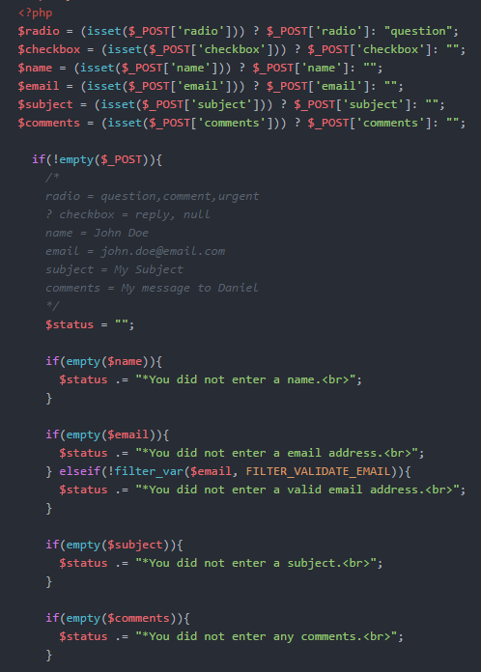

This is the code for sending the verification email.

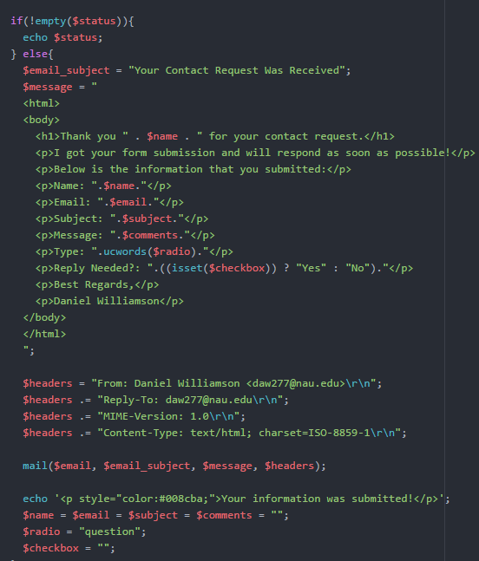

Testing:

If all information inputted was correct you will get a message saying so, and all fields will be restarted.

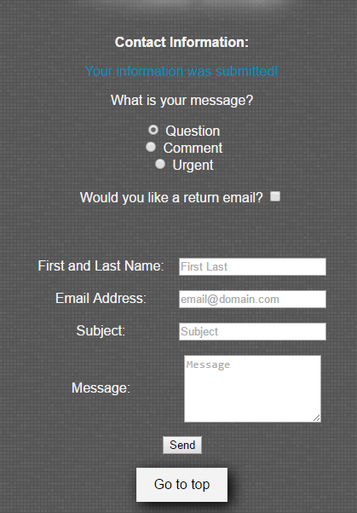

And this is the email you will receive if everything was good.

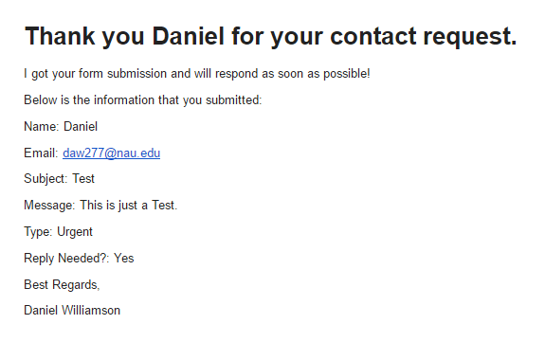

This will be the error message if a field was empty.

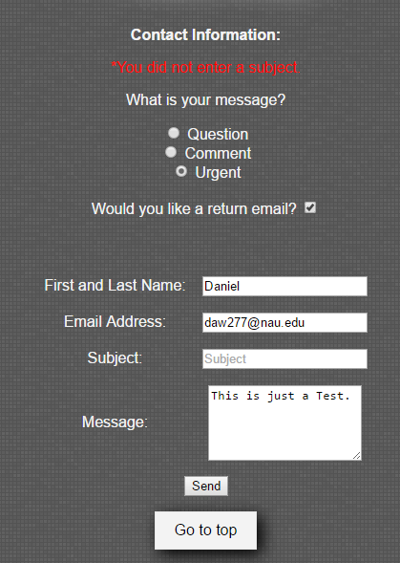

This is if you entered an invalid email address. As in it doesn’t follow the traditional [email@domain.com](mailto:email@domain.com) set up.

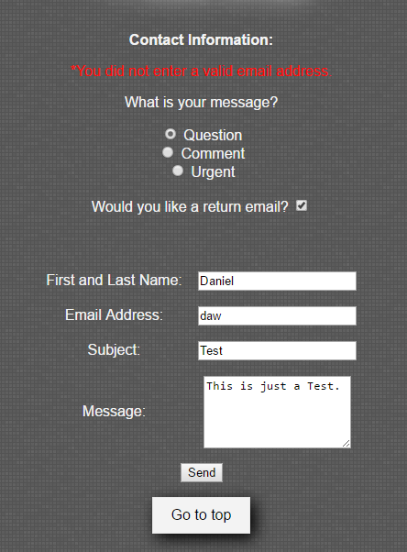

Conclusion

In the end, this was a really fun lab. It wasn’t like the previous projects because PHP is something you can’t visual see. You aren’t busy making your site look good. You are making it more useful. Giving it the ability to do more. I learned a lot from this project and I am looking forward to doing more. The only difficulty I had was getting started with the PHP. I knew you could embed it right into HTML. But, I just didn’t know where to start.